Cointegration and ECM: AUDUSD and USDJPY
Method 27 / Engle-Granger on log closes / one-lag ECM / Alpari D1 full available history

Study setup
Logical pair: PX=AUDUSD , PY=USDJPY
Broker symbols: AUDUSD_i , USDJPY_i
Snapshot: 2026-11-03_majors_alpari_D1
Timeframe: D1
Matched window: 1999-01-05 to 2026-11-02 (UTC bar dates)
Matched level count n: 7199
Dropped unfinished last bar dated 2026-11-03 UTC after a tick-volume check against the prior complete day.
ECM lags of deltas: 1
Complete matched rows (Excel): AUDUSD-USDJPY_Coint_D1.xlsx
Complete matched rows (HTML table): AUDUSD-USDJPY_Coint_D1_data.html

Method carried forward
Engle-Granger cointegration works on log price levels, not returns. For each unordered pair, PX is the left leg and PY the right leg. Step one: OLS ln(PY) = alpha + beta * ln(PX) + e. Step two: statsmodels Engle-Granger coint test on (ln(PY), ln(PX)). Error-correction: delta ln(PY)_t = c + kappa * e_{t-1} + lagged delta ln(PY) and delta ln(PX) (one lag each) + u_t. Headline is the Engle-Granger p-value (lower = stronger evidence of a stationary spread) with kappa and beta reported alongside. Same-sample Pearson r of log returns is a side check only. beta is not an automatic lot-size hedge. This is not a trading signal.

Results (headline)
alpha: 4.534546
beta: -0.618603
Engle-Granger t: -1.676138
Engle-Granger p: 0.687713
5% critical value: -3.336979
ECM kappa: -0.000438
kappa t-stat: -0.7623
ECM R^2: 0.003544
spread std: 0.127195
Pearson r (returns): -0.088151

Conclusion
Engle-Granger for PY=USDJPY on PX=AUDUSD: beta=-0.6186, alpha=4.5345, coint_t=-1.6761, p=0.6877 (5% crit=-3.3370). ECM kappa=-0.0004 (t=-0.76). Pearson r of returns = -0.0882. beta is not a lot-size hedge. Not a trading signal.

Charts
Daily closes

Engle-Granger residual spread
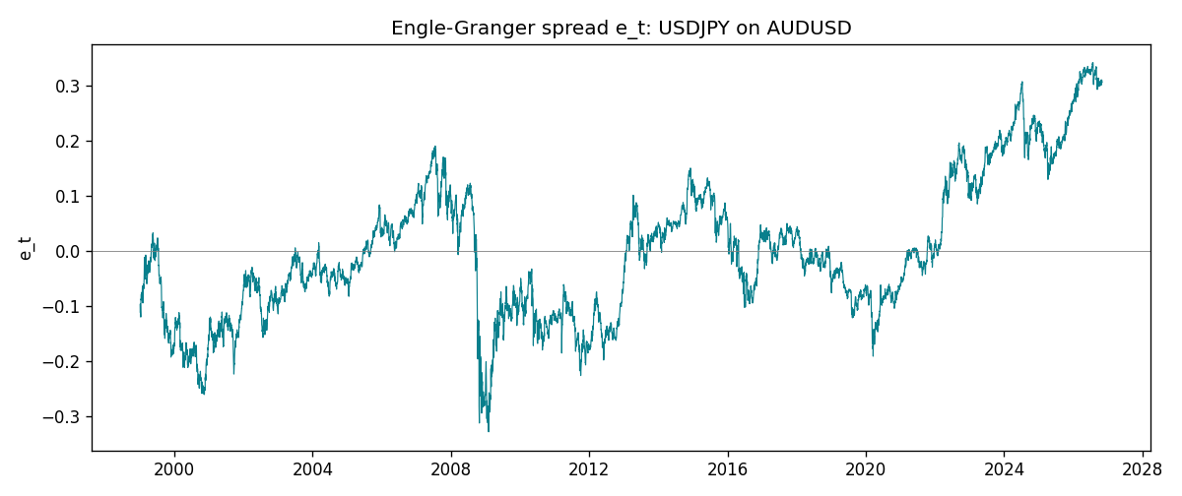
Daily log returns
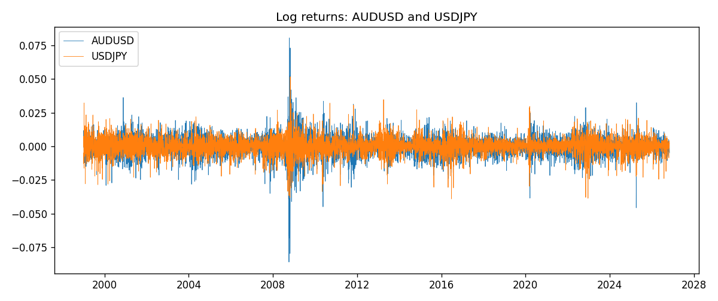

Data report
Matched rows are in the sibling Excel workbook named AUDUSD-USDJPY_Coint_D1.xlsx. Embedding all rows as a Word table is impractical; this file holds column summaries and the first and last 15 matched rows.
Column summaries
column | count | mean | std | min | 25% | 50% | 75% | max
AUDUSD_open | 7199 | 0.75196998 | 0.13527571 | 0.4785 | 0.661035 | 0.73142 | 0.809135 | 1.10284
USDJPY_open | 7199 | 113.81114 | 19.206896 | 75.693 | 104.4285 | 110.984 | 120.6925 | 163.824
AUDUSD_high | 7199 | 0.75602148 | 0.13583632 | 0.4878 | 0.6647 | 0.7349 | 0.815325 | 1.10795
USDJPY_high | 7199 | 114.30872 | 19.268446 | 76.001 | 104.881 | 111.442 | 121.26 | 163.978
AUDUSD_low | 7199 | 0.7479145 | 0.13459018 | 0.4775 | 0.6577 | 0.72758 | 0.80425 | 1.0975
USDJPY_low | 7199 | 113.28779 | 19.134887 | 75.402 | 103.89 | 110.53 | 120.17 | 163.628
AUDUSD_close | 7199 | 0.75202255 | 0.13525884 | 0.4786 | 0.661195 | 0.73175 | 0.809235 | 1.10169
USDJPY_close | 7199 | 113.824 | 19.222288 | 75.811 | 104.42 | 111.025 | 120.687 | 163.851
AUDUSD_tick_volume | 7199 | 77366.826 | 138149.99 | 109 | 5440 | 43349 | 71344.5 | 1234623
USDJPY_tick_volume | 7199 | 106151.62 | 179316.41 | 197 | 9927 | 53098 | 92761 | 1803508
AUDUSD_spread | 7199 | 30.814558 | 16.886804 | 0 | 13 | 30 | 50 | 50
USDJPY_spread | 7199 | 20.321434 | 17.631726 | 0 | 6 | 11 | 30 | 50
AUDUSD_real_volume | 7199 | 5.2435469e+09 | 1.2539788e+11 | 0 | 0 | 0 | 0 | 3.811512e+12
USDJPY_real_volume | 7199 | 3.470603e+10 | 1.6078743e+11 | 0 | 0 | 0 | 0 | 3.8834203e+12
AUDUSD_log_price | 7199 | -0.30074417 | 0.17689082 | -0.7368901 | -0.41370648 | -0.31231635 | -0.21166593 | 0.09684536
USDJPY_log_price | 7199 | 4.7205868 | 0.16778675 | 4.3282434 | 4.6484212 | 4.7097554 | 4.7932004 | 5.0989575
AUDUSD_log_return | 7199 | 2.78e-05 | 0.00754502 | -0.08602525 | -0.00385397 | 0.00028846 | 0.00415332 | 0.0806166
USDJPY_log_return | 7199 | 4.761e-05 | 0.00620532 | -0.03908203 | -0.00320306 | 0.00011368 | 0.00340781 | 0.05184024
spread_e | 7199 | -0 | 0.12719483 | -0.32808182 | -0.09180205 | -0.01415635 | 0.07748494 | 0.34201186
ecm_fitted | 7198 | 4.765e-05 | 0.00036945 | -0.00468368 | -0.00014156 | 2.372e-05 | 0.00020997 | 0.00494271
First 15 matched rows (selected columns)
time | AUDUSD_log_price | USDJPY_log_price | spread_e | AUDUSD_log_return | USDJPY_log_return
1999-01-05 | -0.47561937 | 4.7177843 | -0.1109808 | -0.00080418179 | -0.00017868311
1999-01-06 | -0.46378302 | 4.7253503 | -0.096092783 | 0.011836351 | 0.0075660159
1999-01-07 | -0.45491799 | 4.7124988 | -0.10346044 | 0.0088650256 | -0.012851583
1999-01-08 | -0.45460283 | 4.7077268 | -0.10803747 | 0.00031515916 | -0.0047719894
1999-01-11 | -0.44738145 | 4.6915314 | -0.11976572 | 0.0072213815 | -0.016195423
1999-01-12 | -0.4522423 | 4.7238417 | -0.090462292 | -0.0048608485 | 0.032310364
1999-01-13 | -0.46013251 | 4.731979 | -0.087205882 | -0.0078902098 | 0.0081373171
1999-01-14 | -0.46282943 | 4.731979 | -0.088874202 | -0.002696916 | 0
1999-01-15 | -0.45570632 | 4.7375134 | -0.078933491 | 0.007123101 | 0.0055343401
1999-01-18 | -0.4547604 | 4.737601 | -0.078260739 | 0.00094592471 | 8.7600193e-05
1999-01-19 | -0.44753788 | 4.731979 | -0.079414811 | 0.0072225153 | -0.0056219403
1999-01-20 | -0.4462871 | 4.726591 | -0.084029065 | 0.0012507819 | -0.0053879917
1999-01-21 | -0.44550616 | 4.7350574 | -0.075079565 | 0.00078094498 | 0.0084664056
1999-01-22 | -0.4577589 | 4.7410987 | -0.076617891 | -0.012252745 | 0.0060412564
1999-01-25 | -0.46171805 | 4.7337393 | -0.086426447 | -0.0039591468 | -0.0073594164
Last 15 matched rows (selected columns)
time | AUDUSD_log_price | USDJPY_log_price | spread_e | AUDUSD_log_return | USDJPY_log_return
2026-10-13 | -0.35923536 | 5.0645236 | 0.3077539 | 0.0035007712 | -0.0018932826
2026-10-14 | -0.36075468 | 5.0645994 | 0.30688984 | -0.0015193215 | 7.5800166e-05
2026-10-15 | -0.36829939 | 5.0627469 | 0.30037024 | -0.0075447063 | -0.0018524319
2026-10-16 | -0.36490875 | 5.0623672 | 0.30208793 | 0.0033906408 | -0.00037976126
2026-10-19 | -0.35982275 | 5.0658618 | 0.30872883 | 0.0050859986 | 0.0034946841
2026-10-20 | -0.35636071 | 5.0636072 | 0.3086158 | 0.0034620426 | -0.0022546642
2026-10-21 | -0.35275407 | 5.0632783 | 0.31051804 | 0.0036066384 | -0.00032883504
2026-10-22 | -0.35402133 | 5.0546841 | 0.30113984 | -0.0012672558 | -0.0085942669
2026-10-23 | -0.35164476 | 5.0550349 | 0.3029608 | 0.0023765656 | 0.00035080446
2026-10-26 | -0.35484804 | 5.0591588 | 0.30510311 | -0.0032032829 | 0.0041238746
2026-10-27 | -0.35318105 | 5.0619239 | 0.30889948 | 0.0016669876 | 0.0027651658
2026-10-28 | -0.3490895 | 5.0609671 | 0.31047373 | 0.0040915541 | -0.00095679538
2026-10-29 | -0.35318105 | 5.0605867 | 0.30756225 | -0.0040915541 | -0.00038043789
2026-10-30 | -0.35217082 | 5.059527 | 0.30712754 | 0.0010102376 | -0.0010596481
2026-11-02 | -0.35708932 | 5.0621709 | 0.30672879 | -0.0049184984 | 0.0026438521

